Java script fundamental for automation testing

What we are going to cover

**Java script hello world program**

**Declaring the variable in java script**

**Understanding the data type in java script**

**Loops and conditions in java script**

**Logical operator and assignment in JS**

**Arrays and its methods with detailed example**

**Functions in Jave script.**

**Understanding var, let and const keyword.**

**String and its related functions.**

**What are java script objects.**

**Classes and its properties, Methods in JS**

**Java script hello world program**

We can do this by console.log(“hello world”) method -> save it and run on terminal with node filename.

**Declaring the variable in java script**

In java script at run time its find the variable type.

Type of variable :- var,let,const.

Var hold the variable and it’s a legacy variable . Newly implement in the latest version is let and const. In JS latest version is known as latest engine.

Typeof() is the method which is dind the type of datatype.

Code is

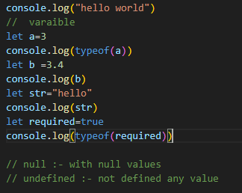

Difference between var and let

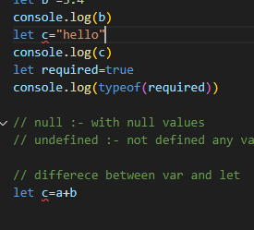

Throwing an error when I declare the c two times

No error when declare with var

So that we can say re declaration is possible in case of var but not possible in let.

Re Assigned is possible in let.

Const :- re declaration is not possible but re assigned.

Loops and conditions in java script.\

Boolean value is true and in if condition its always take the true value in that case if we can forcefully provide the Boolean value as false then its take the false. Below code display as ifelse block.

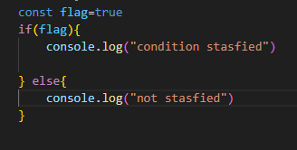

While loop:- first we need to declare the var value then check the condition after that increment the condition.

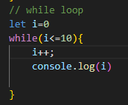

Do-while :- one round of condition is check to run the loop then check the condition .

This is the o/p of do while loop also

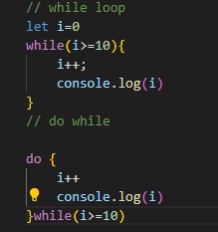

o/p is 1 which is print by d while loop and then terminated however the while loop is not executed.

For loop :- initialize then condition check then increment.

When to use for loop and when to use while loop:- for loop used for iteration and while loop used for statement check.

Code example

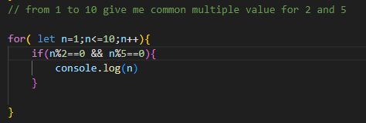

Condition is:- print first three values from 1 to 100 multiple for 2 and 5

Arrays and its methods:-arrays is the collection is an elements.

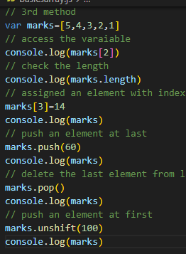

Array operation :- we has done these operations on an array

1. Find indexof
2. Find the element in an array
3. Find sum of the element an array
4. Traverse the array with for loop
5. Slicing an array

To perform the sum from loop iteration with new varaiable sum we can also do with inbuild method (reduce).

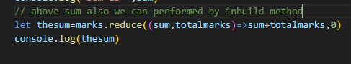

Sum we can declare the value as 0 in last.

Total marks capture the value from marks array.

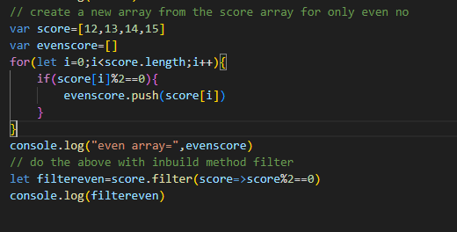

Map array method:- applies the operation on each element however the filter applies on single element.

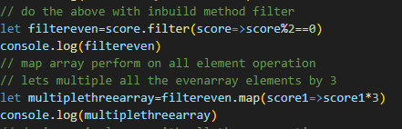

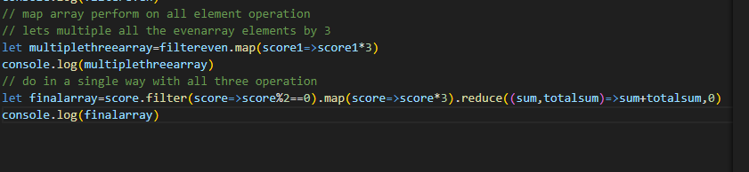

Sorting by the sort method we can do sorting

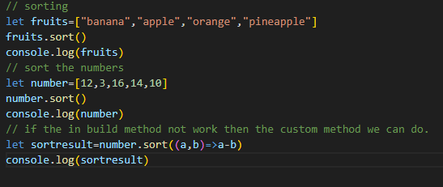

On the numbers sort sometime the sort method not worked. As see the result

o/p for the above

Sort done by the inbuild method not performed correctly but done perfect by the custom method. Logic based on the subtraction result less which comes first.

Reverse :-means updating the number in a reverse order.we can do this by the reverse method. In the custom method when sort the element with a-b same we can do the reverse of element with b-a

Function: function is a block of code. In java script we can defind the function in a different way. Lets see.

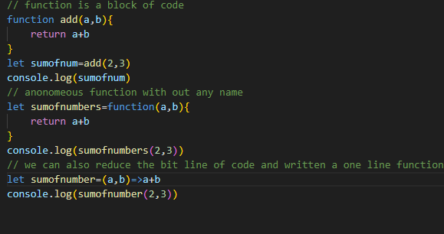

o/p

Variables scope in the functions:- we have the three variables Var,let, const .

Levels to access these

Var:- global level and function level scope :- means if we declare this on global level then we can not access this value from function.

Let:- global level and block level {} means if we declare this value on global and block then its take the last value from block.

Const :- we can not re declare or re assigned the value it’s a const .

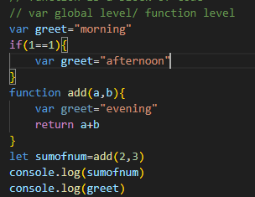

o/p for greet is afternoon

from let to resolve this issue

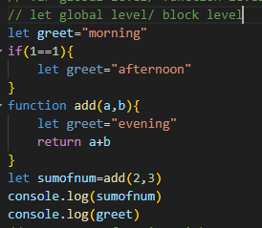

o/p is morning

const also not change the value

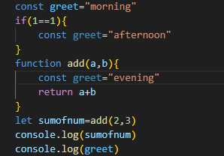

String and its method in java script

String is the collection of element w.r.t array is the collection of element. We can write down the string in a single quote and double quote.

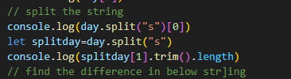

How we can find the difference between the string . we can not do the difference in a string only we need to convert this as an integer format.

Let date =’23’

Let nextdate=’27’

Let diff=nextdate-date

Console.log(diff)

Its thrown an error because only integer we can do the difference not with a string so that we can do the parsing of the string method is parseInt(date).

Again conversion from int to string by tostring() method

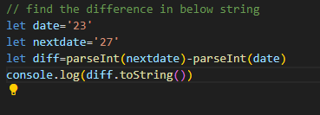



Methods are :- concate and indexof

Concatenate:- combined the two strings.

Indexof:- find the character of the string or do the search in string.

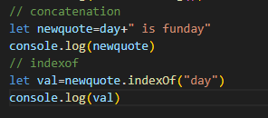



Lets we need to find the next day from Tuesday then we can give the next index corresponding index from current one .let say first day is find on 4th index then we can give the 5th index in search string.

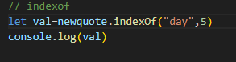

Program to find the occurrence of day in the string when we compare the value with -1 that’s means not found any value.

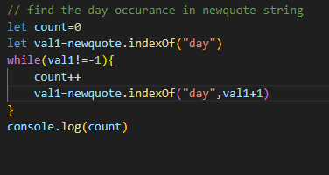

Classes and Object:- object is the collection of properties.in the below diagram we can see that person is the object and firstname and lastname are the properties.

We can see the feature of the properties.

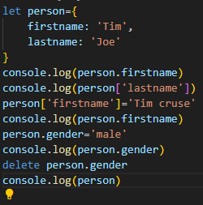

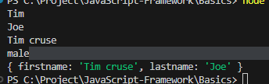

Extended the properties of the class and added few more properties like fullname combination of firstname and lastname with done by function()

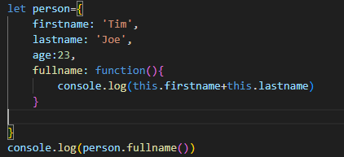

How to search the properties in the person object.

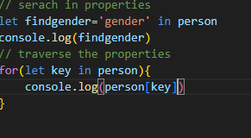

Classes :- class is the collection of the objects and properties . we can define the class under it the properties, function with getter, constructor and single function.

When we declare the function with getter then its act as a properties.

Constructor:- this is the class method which is executes everytime when the object is been created.

Instance variable:- variables which is passed under constructor at run time act as a instance variable.

Class variable:- declare the variable under the class.

Local variable :- declare inside the functions .

This keyword:- declare the local variable inside the function.

Construcor() represent the constructor in a class takes the instance variable at run time and the variable declare with this keywork which works under the class only not outside the class .

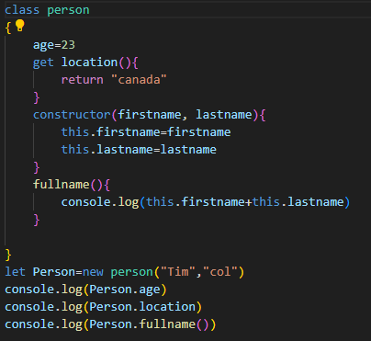

Second variable with different values passed

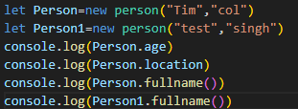

Class import and export:- suppose I have created one class name as class person with methods that’s method of the class I want in second class member. So that for person class we need to use export keyword and for import we can use the required keyword.

Class 1 export

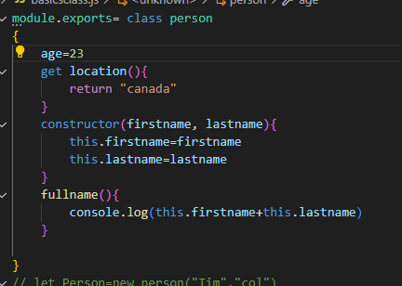

Class 2:- import

o/p

Inheritence:- extends oen class from the another class , we can extends the constructor of the parent class with super keyword.

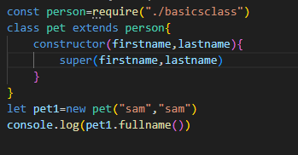

We need to first import the parent class and then exteds this with parent class. After we can create the object of child class and call the methods

Overridden the location

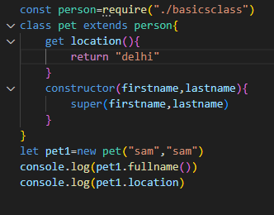

Note :- we need to export the parent class in case of export / import or in case of inheritance.

o/p

